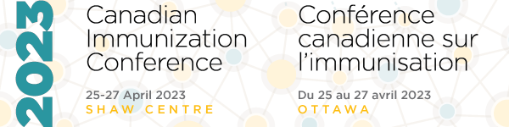

Co-developed Learning Activity Sessions
Organization
Contact name |  | Position
Address |  | City
Province/Territory |  | Postal code
E-mail |  | Telephone
Session notes
Detailed Proposal
All proposals must be submitted to secretariat@cic-cci.ca and received by
17:00 (ET) on Thursday 15 December 2022
Prescribing demographic | Paediatric |  | Adult
Proposed title
Session description (maximum 150 words)
Learning objectives
At the end of this session, participants will be able to
Learning needs
Describe how the learning needs of the target audience determined
Proposed faculty
List up to three proposed faculty and their affiliations
Proposed faculty contact  Indicate the e-mail/phone for the proposed faculty | E-mail |  |  | Phone
 | E-mail |  |  | Phone
 | E-mail |  |  | Phone

