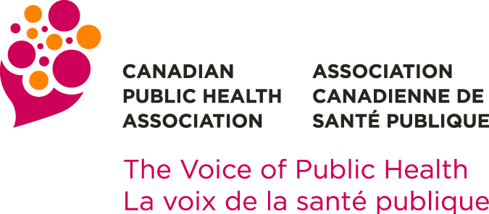 | 2023 Honorary Awards Nomination Form  National Public Health Hero Award  Deadline for applications: 14 February 2023

Nominee (Any individual, group or organization engaged in community work)
NAME
ADDRESS
CITY |  |  | PROV |  |  | POSTAL CODE
OFFICE TELEPHONE |  |  |  | HOME TELEPHONE
E-MAIL

Nominator (Must be a CPHA Member-in-good-standing)
NAME
ADDRESS
CITY |  |  | PROV |  |  | POSTAL CODE
TELEPHONE (work) |  |  |  | TELEPHONE (home)
E-MAIL

Nominee Documentation
Because the CPHA Awards Committee must review all nominations it receives on the basis of the written description of the nominee, it is extremely important that Nominators carefully submit all of the documentation requested below.

- Statement of Nomination
Provide a brief description of the nominee (250-word maximum) and describe why this individual should receive the award. Consider the following: Who has been affected and what are the impacts and/or outcomes of the nominee’s action(s). This information may be used for public dissemination purposes.

INSERT STATEMENT OF NOMINATION BELOW

- Letters of Recommendation
Two (2) sponsors (exclusive of the nominator) should submit letters of recommendation by e-mail (in Microsoft Word (.doc or .docx) or PDF format) in support of the nominee. Sponsors are not required to be a CPHA member.
Awards Committee
Canadian Public Health Association
404-1525 Carling Avenue, Ottawa, ON K1Z 8R9
awards@cpha.ca

CPHA keeps all nominations confidential to respect privacy and to avoid disappointment if the nominee is not selected. We ask that nominators and others involved respect this policy.

